**EX NO 2: DATE:02.02.2025**

**NAME:V.UDHAYAKUMAR**

**ROLL NO:230701367**

**CHUNKING**

**AIM:**

To create a memory recall task game using chunking method in figma.

**PROCEDURE:**

**A. Home Screen (It contains Instruction Page)**

**Step 1: Create a Frame:**

* In Figma, create a new frame (File → New Frame). Set the size to 1024x768px for a standard desktop view.

**Step 2: Add Instructions:**

* Use the Text Tool (T) to add a heading like “Memory Recall Task”
* Add a smaller body of text with instructions such as:
* “You will be shown several groups of icons or text. After viewing,   
  recall the items you remember”
* Use the Text Tool (T) to add more detailed instructions like “You will have 5 seconds to view the items. Then, recall them in the next screen.”

**Step 3: Start Button:**

* Create a button at the bottom of the screen. To do this:▪ Draw a Rectangle (R) for the button.
* Use the Text Tool (T) to add “Start.”
* Style the button (color, border radius) to make it stand out.
* Use Figma’s Prototyping Tools (top bar → Prototype) to link this

button to the next screen (Chunking Phase).

* You can also use interactive components like hover effects for

More realism.

**OUTPUT:**

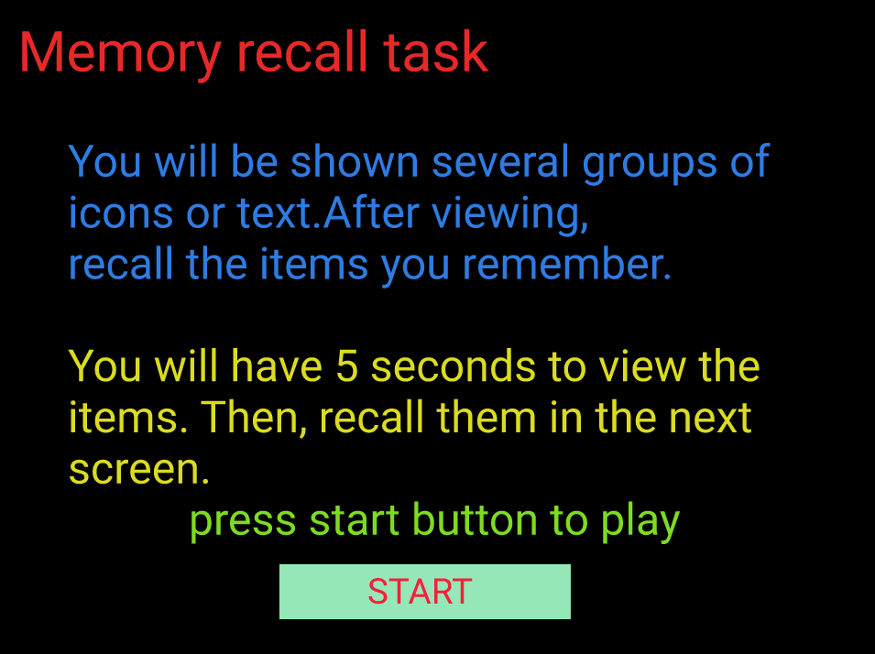

**B. Chunking Phase (It Display Chunked Items)**

**Step 1: Create a New Frame:**

* Create a new frame for the Chunking Phase (the second screen). This frame will display the icons or text.

**Step 2: Design Chunked Items:**

* Use icons or text blocks that users will have to recall. Import them from assets by searching “icons”.

**For Chunking with Borders:**

* ▪ Group 3-5 icons or text together in a box (use the Rectangle Tool (R))
* ▪ Space these chunks out with some empty space in between them to

ensure users can identify each chunk.

**Step 3: Set the Viewing Time:**

* Time Simulation: Figma does not have true timers, but you can simulate fixed time by setting the next screen transition after 5 seconds:
* Select the entire Frame (Chunking Phase).
* Under the Prototype tab, link this frame to the next screen (Recall

Phase).

* Set the interaction to “After Delay” and enter 5000ms (5 seconds).

**OUTPUT:**

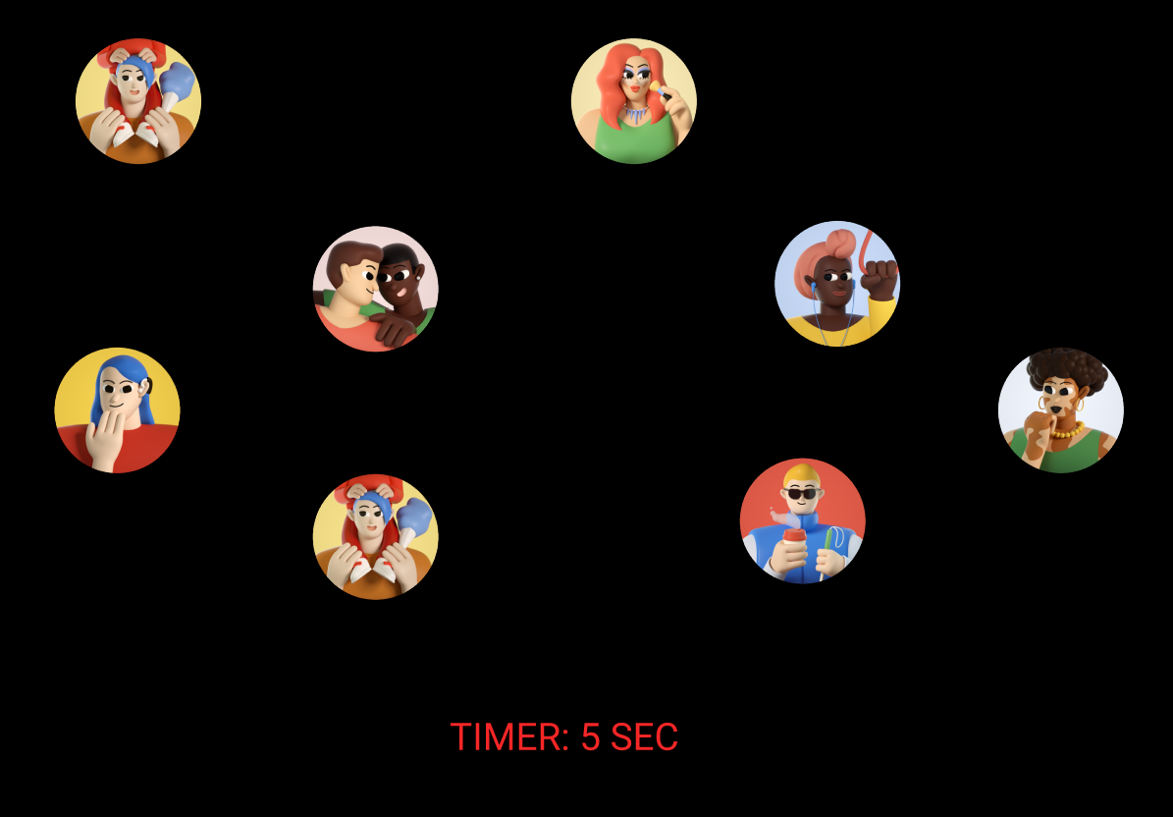

**C. Recall Phase**

**Step 1: Create a New Frame for Recall:**

* This is where the user will recall the items they saw in the previous chunking phase.

**Step 2: Recall Input (Text Input):**

* Create Text Input Fields where users can type what they remember.
* Create 5 input fields depending on how many chunks you showed.

**Step 3: Submit Button:**

* Create a Submit button at the bottom using the Rectangle Tool (R) and

adding text like “Submit”

* Add an interaction to move to the Feedback Screen after submission.
* Sample Output of the Visual Appearance of the Recall Phase (Step C) in Figma

**OUTPUT:**

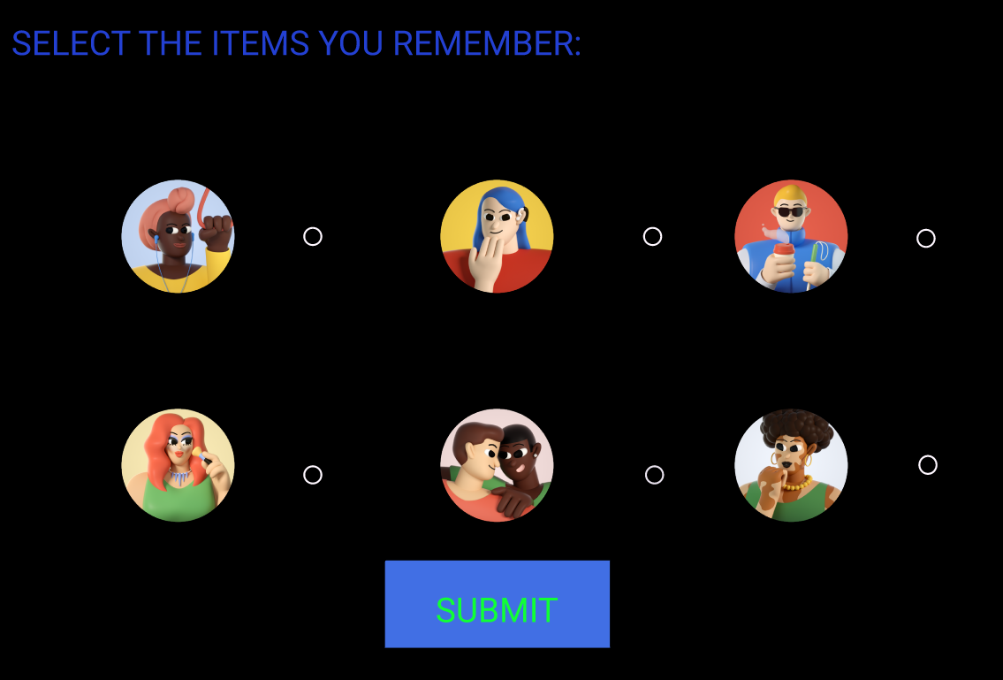

**D. Result Screen**

**Create a Feedback Screen:**

* After the user submits their recall, provide feedback.
* Add text like: “Good job you remembered 5/5”

**OUTPUT:**

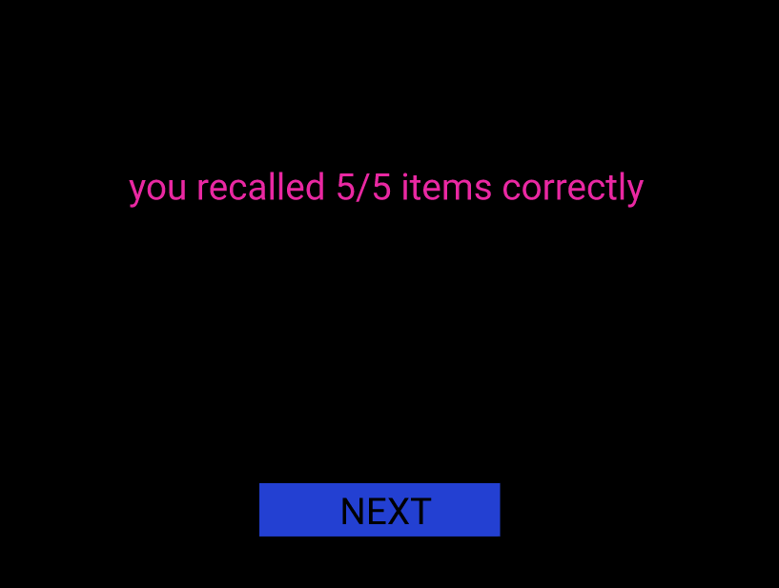

**FIGMA DESIGN FILE:**

[**Chunking**](https://www.figma.com/proto/OtrqFzWm5XO9AUFtZmvyBl/Untitled?node-id=3-2&t=iYPzZGJSpqX6pTKj-0&scaling=contain&content-scaling=fixed&page-id=0%3A1)

**RESULT:**

Hence , memory recall task using chunking method was studied successfully.